CONDUCTORS' GUILD SUPPORTS THE NEXT GENERATION OF THE ROYAL LOGISTIC CORPS

On Wednesday, 5 August 2026, Guild Chairman Dave Patterson, Guild Secretary Steve Swales and serving Conductor Paul Whiteley attended the Royal Logistic Corps (RLC) Stable Belt Presentation at the Army Foundation College (AFC), Harrogate.
The ceremony marked a significant milestone for junior soldiers (JS) who, having successfully completed four months of basic military training and education, were formally welcomed into the RLC. During the event, each soldier was presented with their RLC Stable Belt, rank slides and RLC flash insignia, symbols of their pride, achievement and belonging within the Corps.
The presentations were made by the Corps Sergeant Major, Wayne Marquis, supported by Guild representatives.
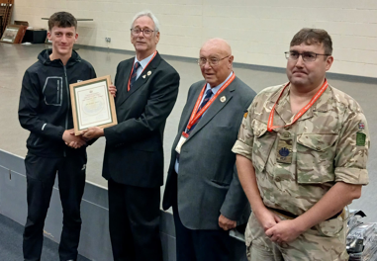
A particular highlight of the event was the presentation of the Conductors' Guild Certificate to JS Mewton-Daley of 15 Platoon, Peninsula Company, who was recognised as the outstanding RLC JS. Following a well-earned week's leave, he will continue his military training at Worthy Down before attending the Defence Driving School at Leconfield to gain his military driving qualifications. He will then join 29 Regiment RLC at South Cerney, home of the Mover fraternity, to begin the next stage of his Army career.
L to R: JS Mewton-Daley, Dave Patterson (Guild Chairman), Steve Swales (Guild Secretary) Conductor Paul Whiteley (Guild Member)
To find out more about 29 Regiment and what today’s ‘Mover’ do, click; 29 Regiment RLC | The British Army
Following the presentation, the Guild members took the opportunity to meet socially over an evening meal at the Royal Bath Restaurant in Harrogate, strengthening the friendships and camaraderie that have always been at the heart of the Conductors' Guild.
The following day, the group returned to AFC Harrogate to witness the Graduation Parade, where 630 junior soldiers proudly passed out on completion of their initial military and educational training. The parade was inspected by Major General Owen Bunkle (Late RLC), Director Support Army Command, Army HQ, Andover, who congratulated the soldiers on their achievements and wished them every success as they embark on their military careers.
Supporting events such as these reflects the Conductors' Guild's commitment to encouraging and inspiring the next generation of RLC soldiers while promoting awareness of the prestigious appointment of Conductor. Every Conductor began their own journey as a young soldier, taking those very first steps in military service.
Among the 630 soldiers who marched proudly on parade this week could well be one, or perhaps several, future Conductors.
As they begin their Army careers, we wish each and every one of them every success. We look forward to watching them grow into skilled logisticians, respected leaders and proud custodians of Corps values. In years to come, some may earn the privilege of wearing the Conductors' Badge of Office and take their place among the Army's most respected Warrant Officers.

